**ETL Screenshots**

**Loading Date Dimension**

**1.** Staging Date from External source to StgDate

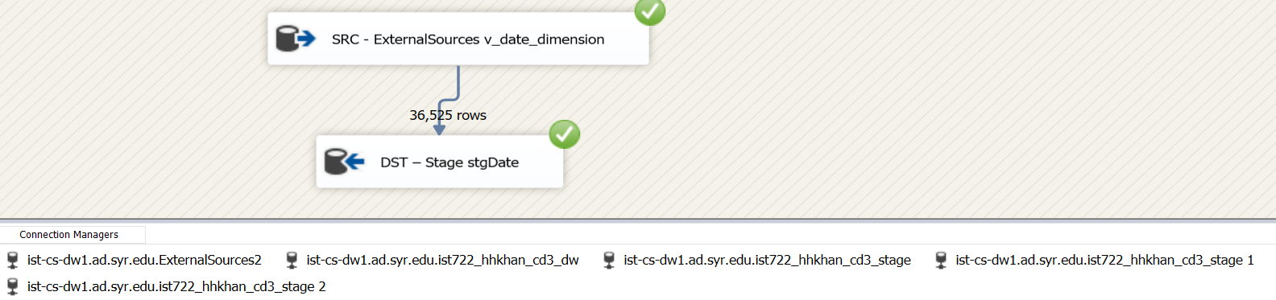

2. Loading Date from stgDate to DimDate

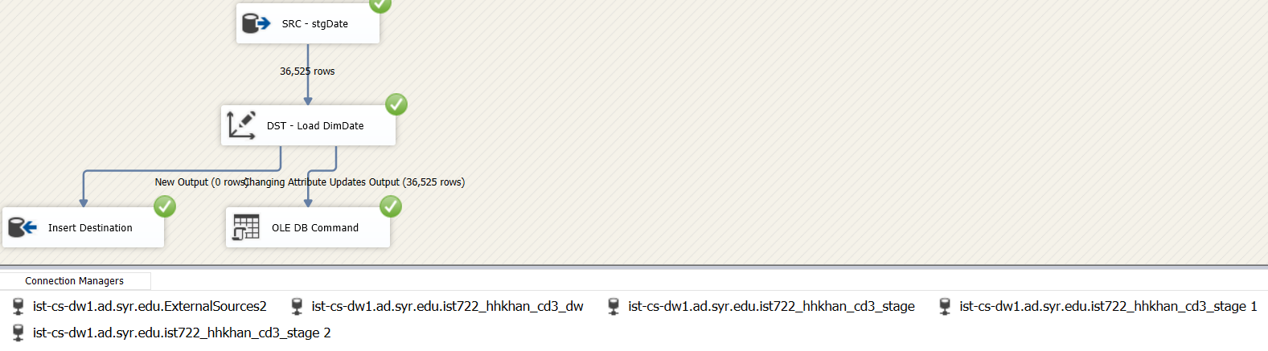

3. DateDimensionImport.dtsx SSIS Package

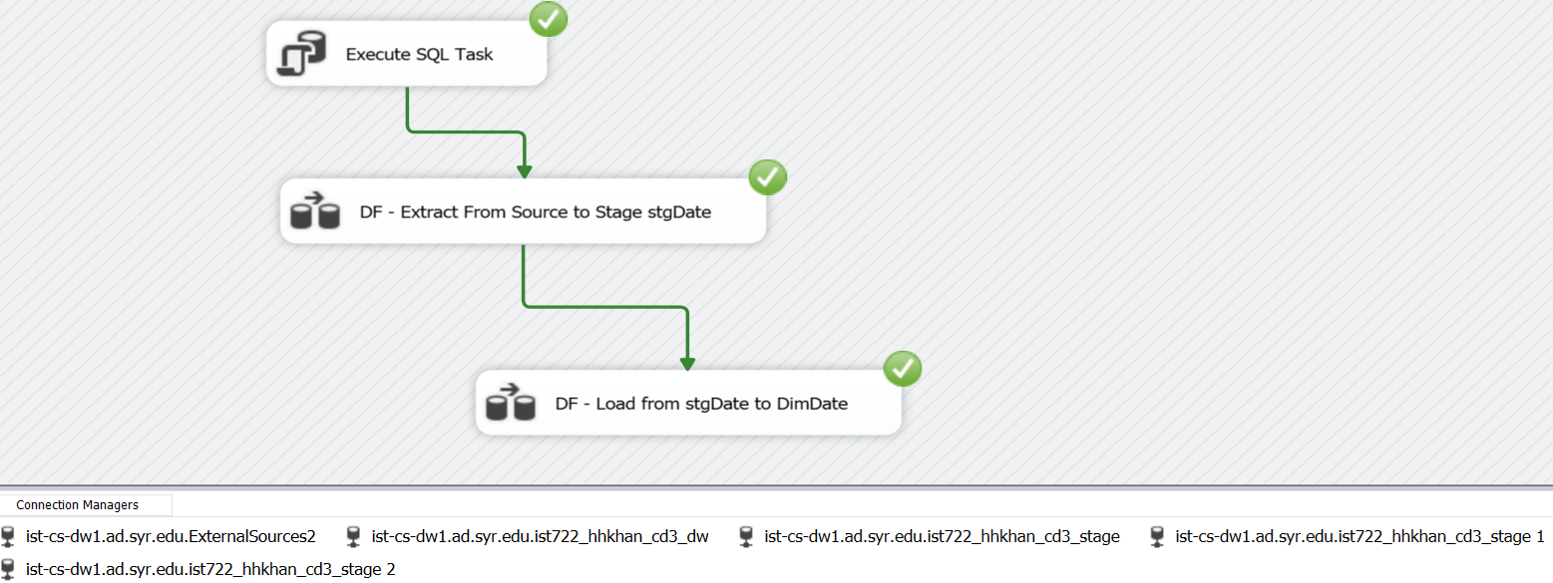

**Staging of FudgeMart**

**1.** Staging FudgeMart Customers to Fcorp_Stage_FMCustomers

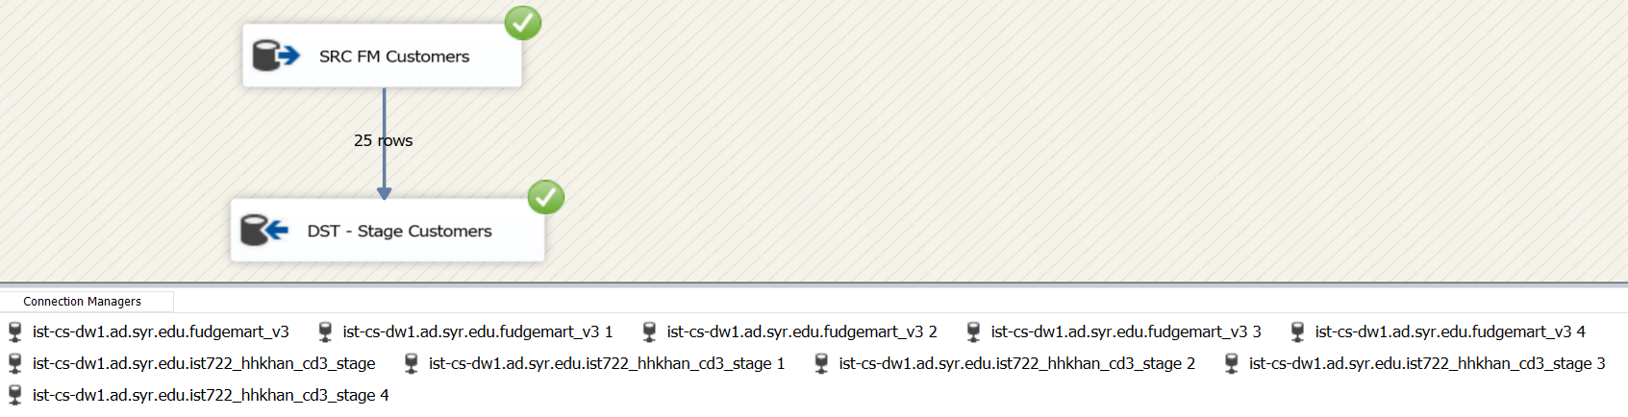

2. Staging FudgeMart Products to Fcorp_Stage_FMProducts

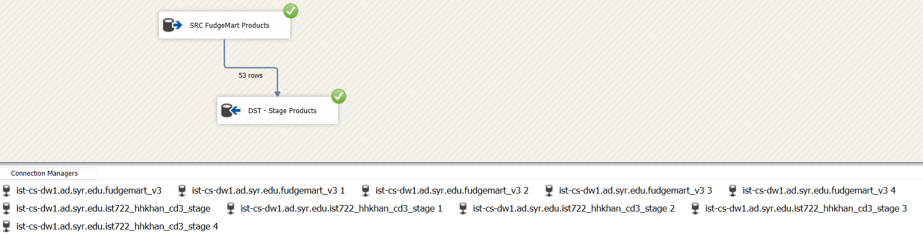

3. Staging FudgeMart Orders to Fcorp_Stage_FMOrders

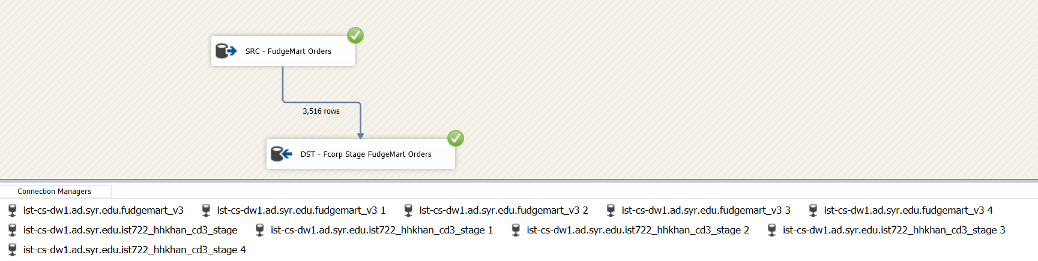

4. Staging FudgeMart FactSales to Fcorp_Stage_FMFactSales

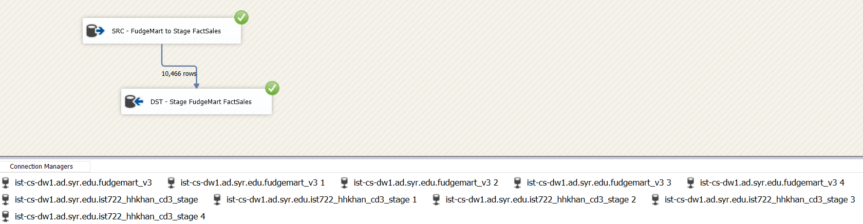

5. FudgeMart_Stage_Sales.dtsx SSIS Package

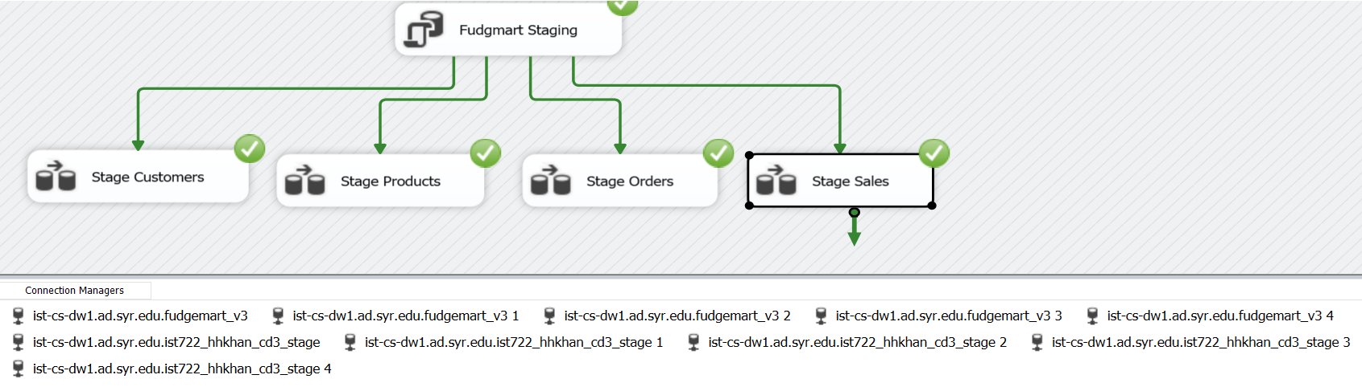

**Staging of Fudgeflix**

**1.** Staging Fudgeflix Accounts to Fcorp_Stage_FFAccounts

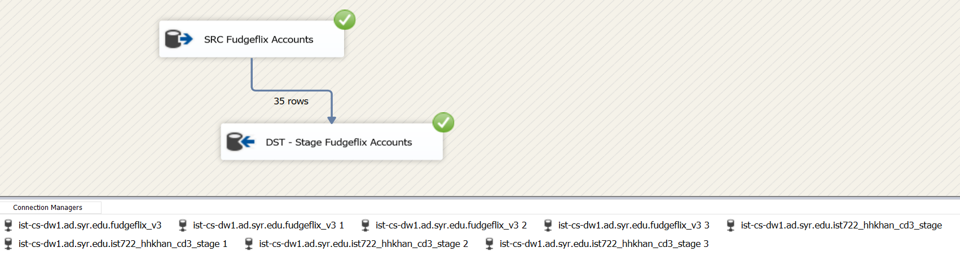

2. Staging Fudgeflix Plans to Fcorp_Stage_FFPlans

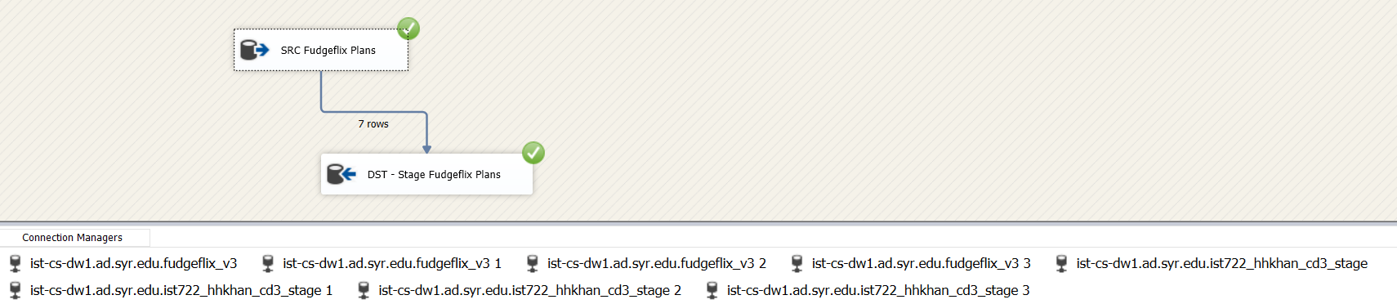

3. Staging Fudgeflix Account Billing to Fcorp_Stage_FFOrders

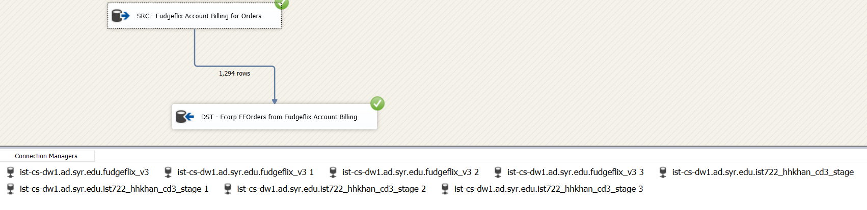

4. Staging of Fudgeflix FactSales to Fcorp_Stage_FFFactSales

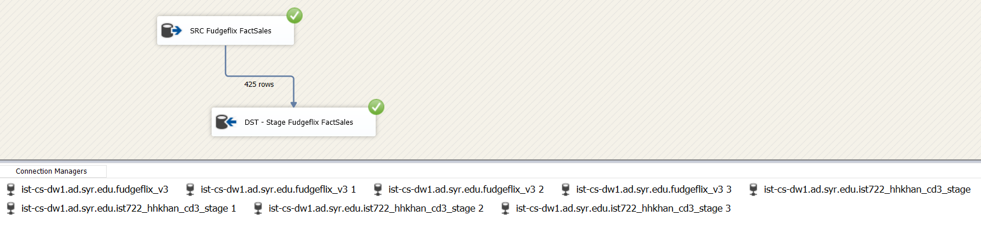

5. Fudgeflix_Stage_Sales.dtsx SSIS Package

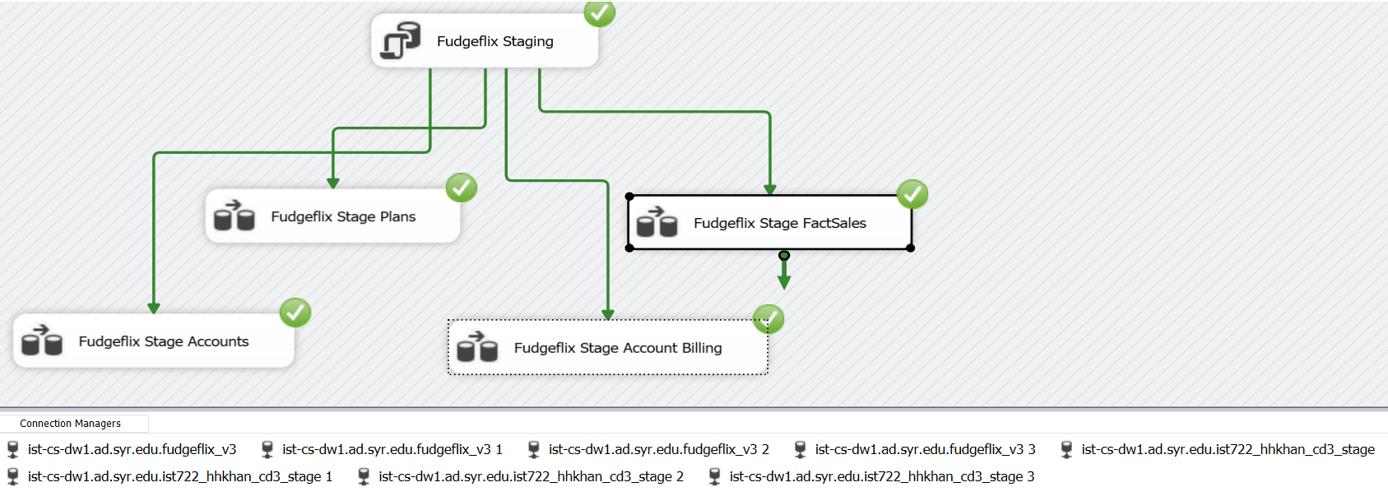

**Loading of Fudgeflix**

1. Loading Fudgeflix Accounts to DimCustomer

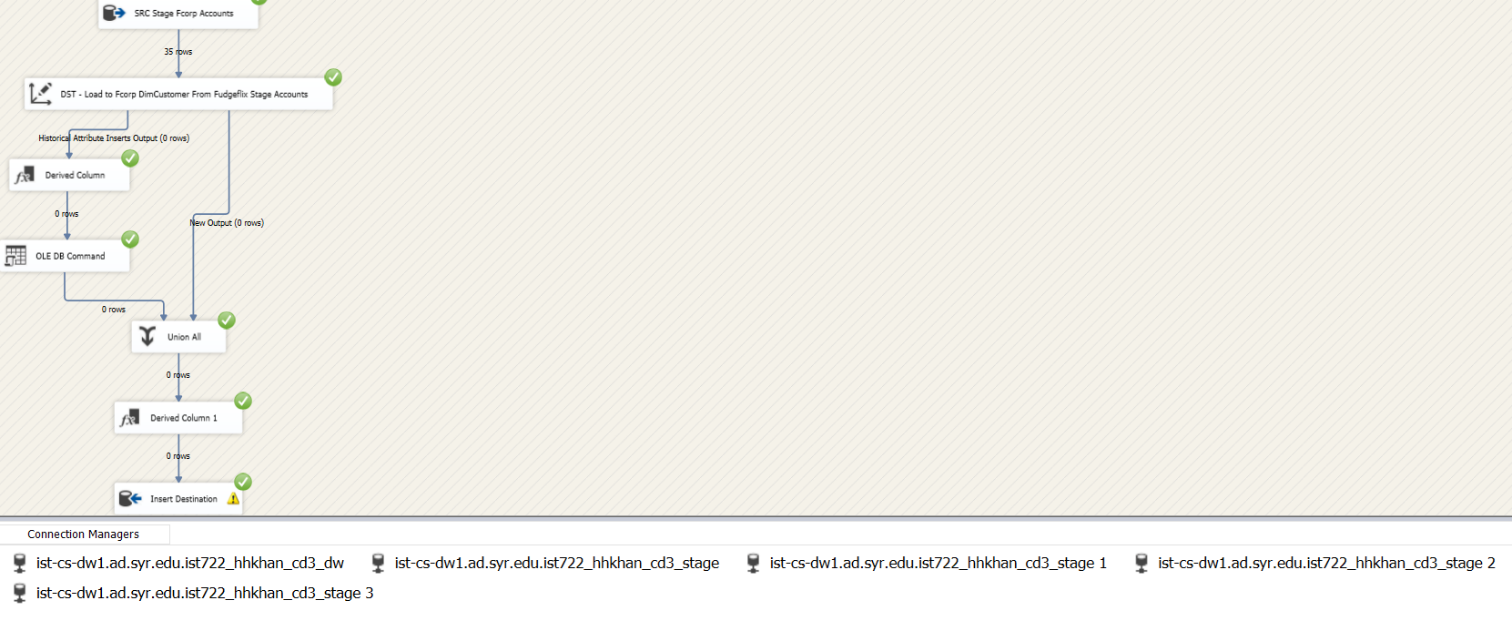

2. Loading Fudgeflix Plans to DimProduct

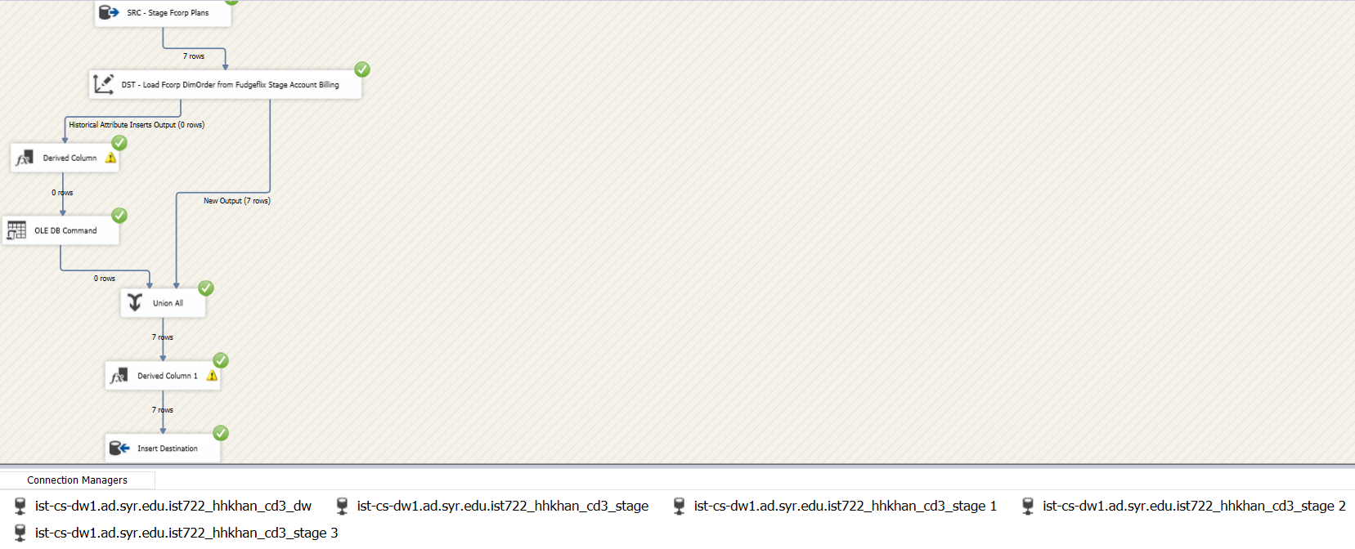

3. Loading Account Billing to DimOrder

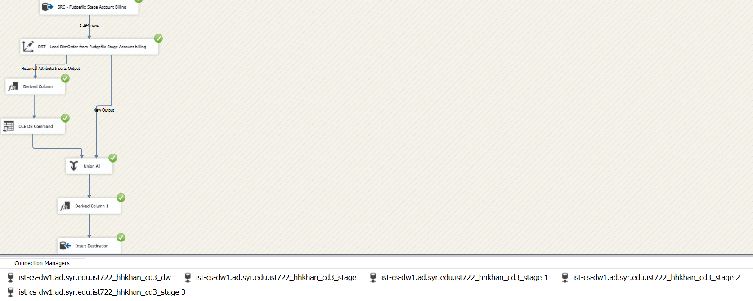

4. Loading Fudgeflix FactSales to Fcorp Factsales

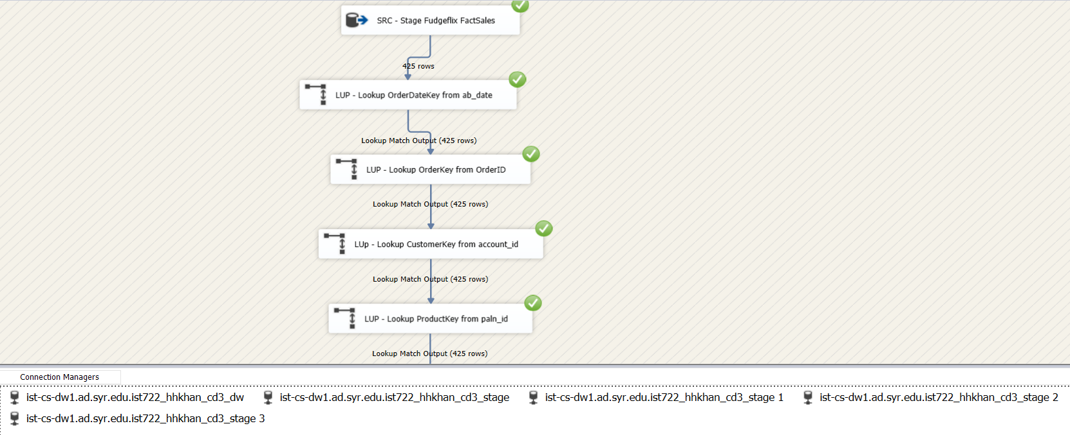

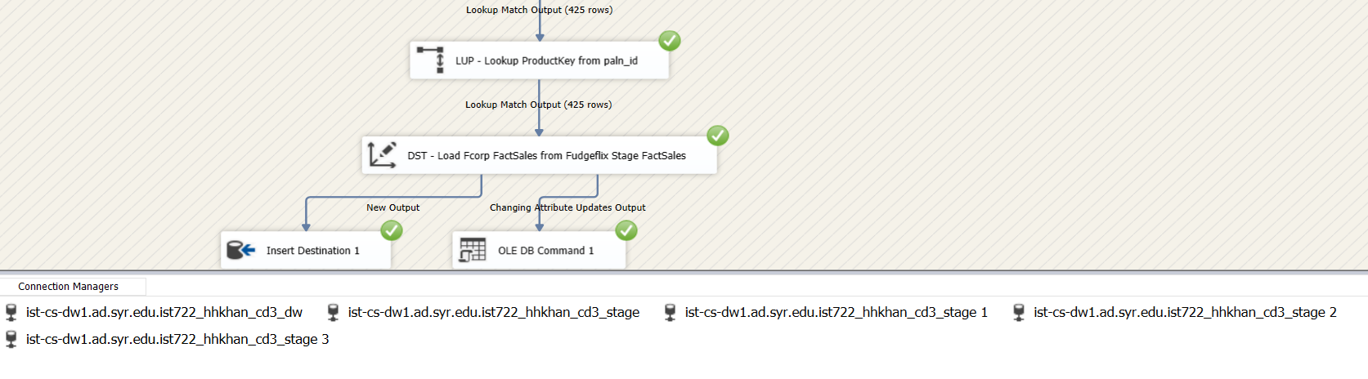

5. Dw_Fudgeflix_Sales.dtsx SSIS Package

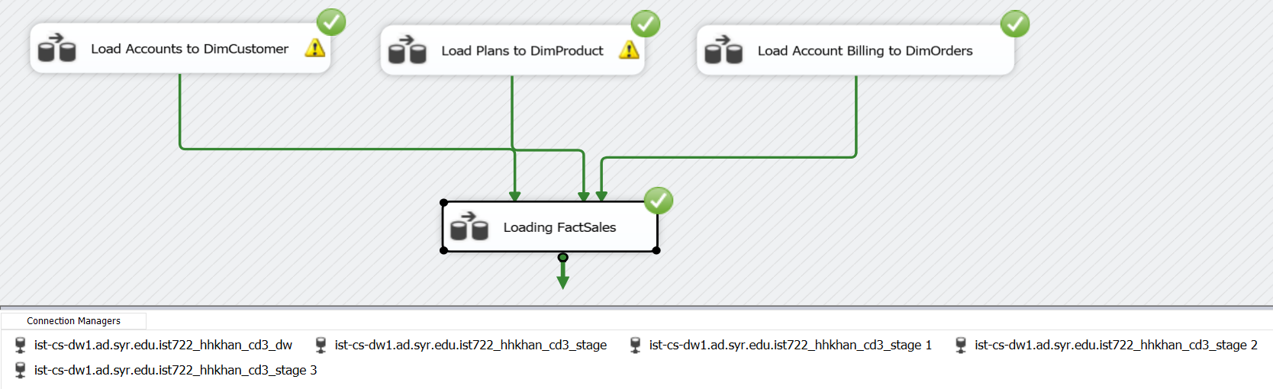

**Loading of FudgeMart**

**1.** Loading of FudgeMart customers to DimCustomers

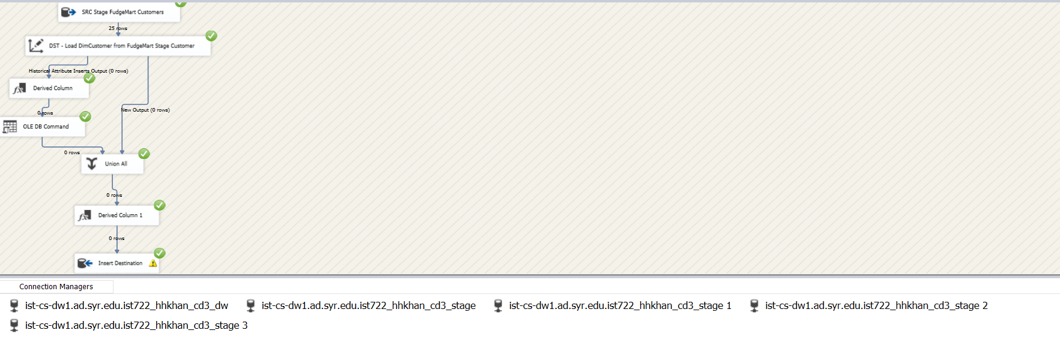

2. Loading of FudgeMart Products to DimProduct

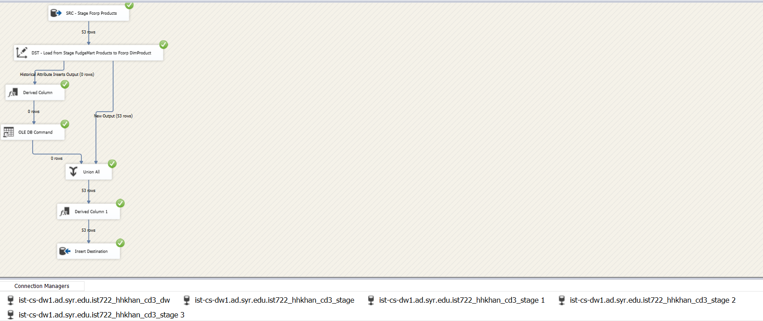

3. Loading of FudgeMart Orders to DimOrder

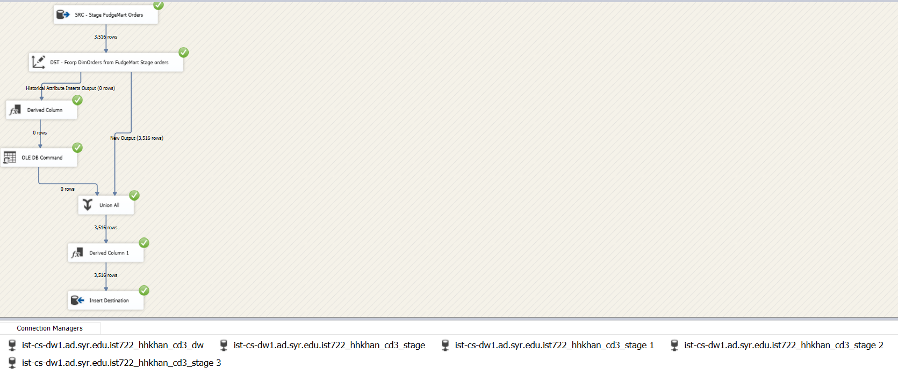

4. Loading Fudgemart FactSales to Fcorp FactSales

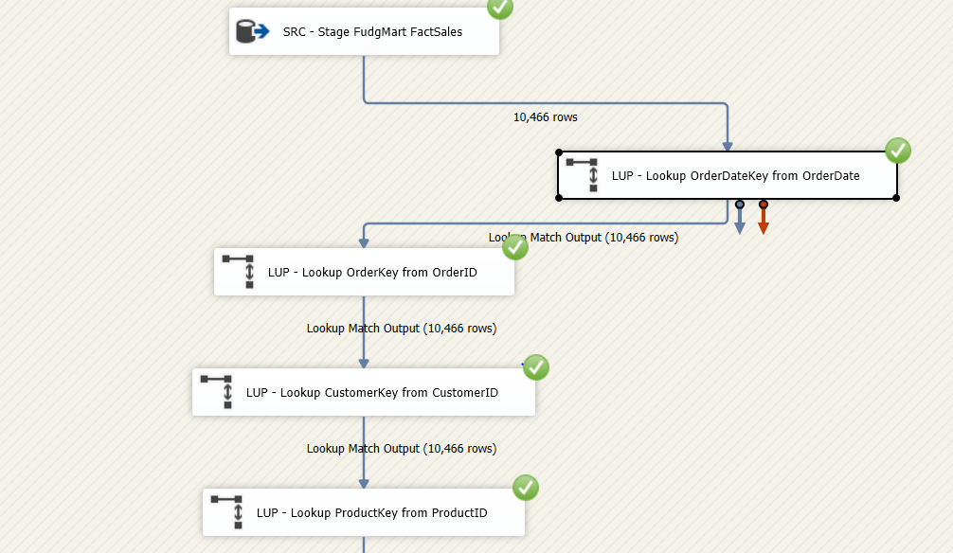

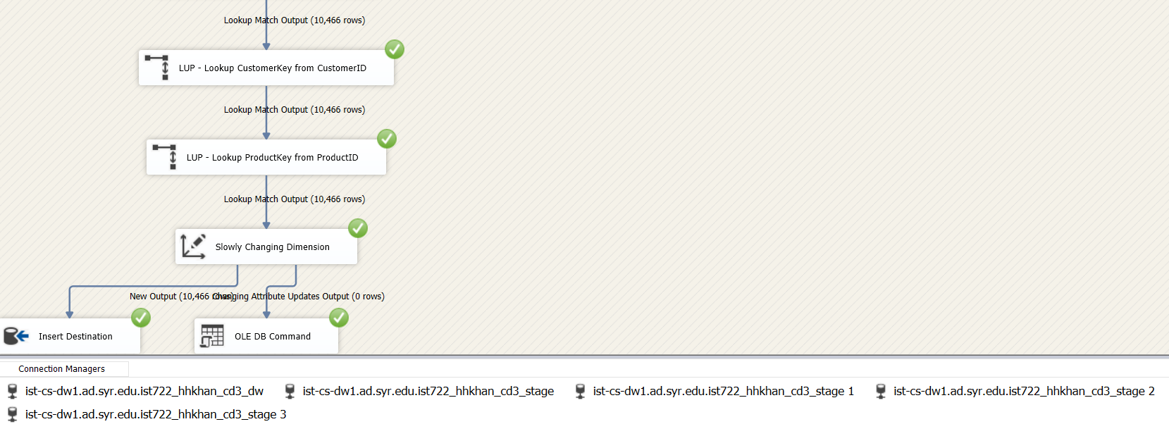

5. DW_FudgeMart_Sales.dtsx SSIS Package

